

**The Sadkane School for Aikido is Celebrating our**

**7th Anniversary with USAF Instructors**

**Peter Bernath – 7th Dan Shihan**

**Penny Bernath – 6th Dan Shidoin**

**Youssef Sadkane – 4th Dan Shidoin**

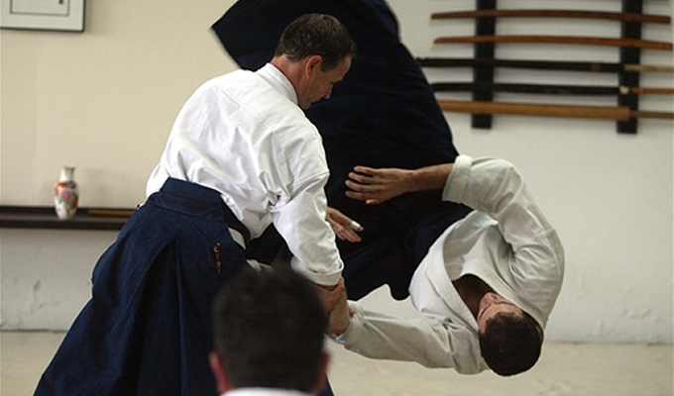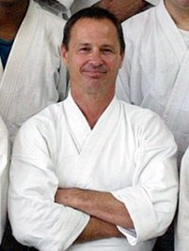

SATURDAY

APRIL 19TH

10am-1:30pm

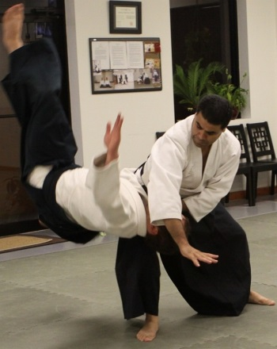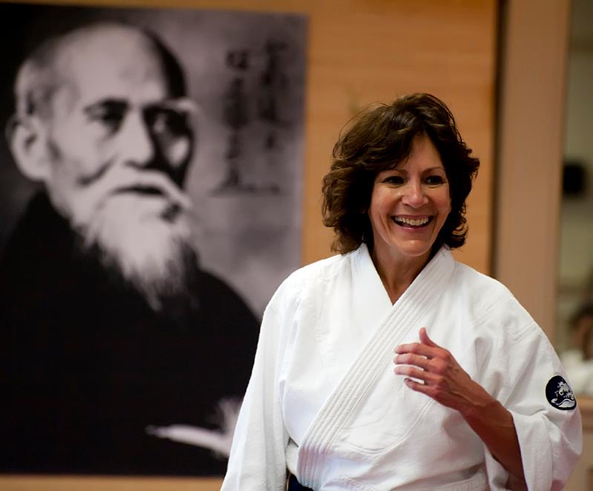  
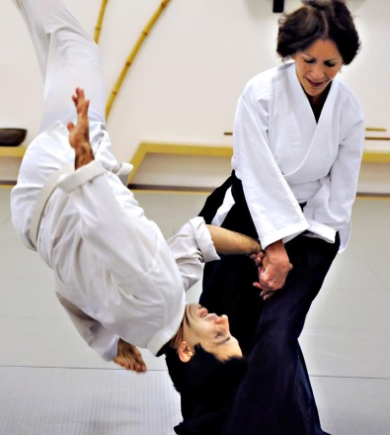

The Sadkane School for Aikido

Village Center Plaza

1037 West State Road 434

Winter Springs, FL 32708

Seminar Cost: $40

We will be having lunch together in Orlando after training at

[*Devaney's Sports Pub*](https://www.facebook.com/devaneyssportspub) in Winter Park

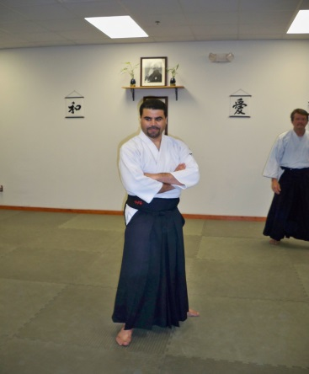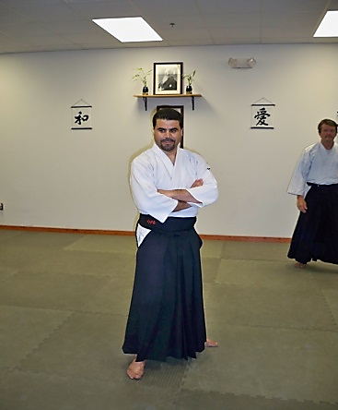  
 [www.sadkaneaikidoschool.com](http://www.sadkaneaikidoschool.com) (407) 491-3209

Please join us for a few hours of excellent instruction. All affiliations are welcome!